**Consume CDS View in ABAP**

Method 1 – Using Select query and cl_display_data method

CDS View

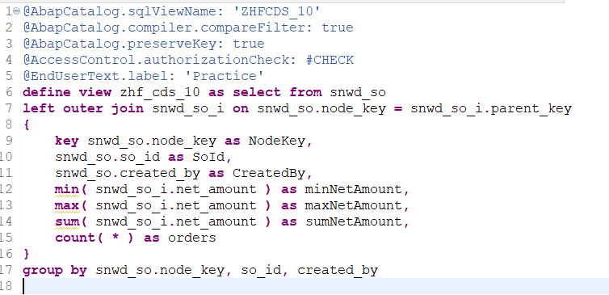

Program

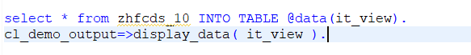

Method 2 – Using class method of class cl_salv_gui_table_ida



Method 3 – For Association

CDS Program

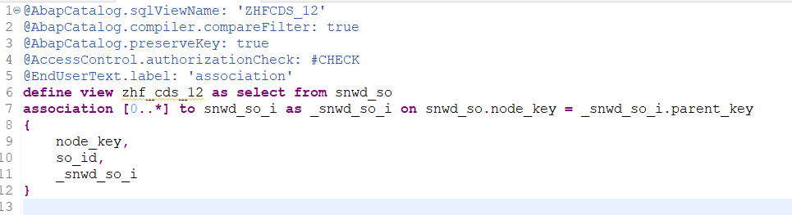

Program

